|  |  |  |
| --- | --- | --- |
| Module Code: **PUSL3108** | Module Name: **Pervasive Computing** | |
| Coursework Title: **Smart Home and Smart Lock System with more Improvements** | | |
| Deadline Date**: 15th of May 2020** | | Member of staff responsible for coursework: **Mr. Craig Banyard** |
| Programme: **BSc (Hons) Software Engineering** | | |
| Please note that University Academic Regulations are available under Rules and Regulations on the University website [www.plymouth.ac.uk/studenthandbook](http://www.plymouth.ac.uk/studenthandbook). | | |
| Group work: please list all names of all participants formally associated with this work and state whether the work was undertaken alone or as part of a team. Please note you may be required to identify individual responsibility for component parts.  **D. P. I. Gayantha 10638279**  **K. H. M. Kavinda Maduranga 10638236**  **H. P. W. N. Hasaranga 10638200**  **P. C. N. Dissanayake 10638271**  **S. S. Bandara 10638294**  ***We confirm that we have read and understood the Plymouth University regulations relating to Assessment Offences and that we are aware of the possible penalties for any breach of these regulations. We confirm that this is the independent work of the group.***  Signed on behalf of the group: C:\Users\DigitalForce™\AppData\Local\Microsoft\Windows\INetCache\Content.Word\Sign.jpg | | |
| Individual assignment: ***I confirm that I have read and understood the Plymouth University regulations relating to Assessment Offences and that I am aware of the possible penalties for any breach of these regulations. I confirm that this is my own independent work.***  Signed : | | |
| Use of translation software: failure to declare that translation software or a similar writing aid has been used will be treated as an assessment offence.  I *have ~~used~~/not used translation software.  If used, please state name of software………………………………………………………………… | | |
| **Overall mark _____% Assessors Initials ______ Date_________** | | |

|  |
| --- |
| Name: **Mr.** **Gayantha, D. P. I.** |
| Student Reference Number: **10638279** |



DISTRIBUTED SYSTEMS | ASSIGNMENT

**PERVASIVE COMPUTING**

PROJECT PROPOSAL

GROUP P

ACKNOLEDGEMENT

I would like to express my special thanks and gratitude to my Pervasive Computing module lecturer Mr. Craig Banyard who gave us the priceless opportunity to do this project on various topics, which also helped us in doing a lot of Research and we came to know and have to study so many new things I am really thankful to them and the Plymouth University.

Secondly, I would like to thank our program Director Dr. Rasika Ranaweera for giving us tremendous support and looking after us.

Finally, I am grateful to all of those with whom I have had the pleasure to work during this project within the limited time frame. Each of the group members committed necessary tasks within this time period.

Best Regards,

D. P. I. Gayantha (Group Leader of Group 15 (DLE Group list))

TABLE OF CONTENTS

# PART A

Introduction6

Smart Beds6

Smart Locks9

# PART B

Smart Bed For more Uses12

INTRODUCTION

We are in a Transition Era of Cognatic Computing to Infinity Computing. Therefor people are experiencing technologies in many forms in their day to day life. Some technologies can be used whenever you want, some technologies are interconnected nodes in geographically different locations to fulfil their scheduled tasks, while some are working as interconnected and speeded computers.

From above technologies IoT plays an authentic role, whenever devices need to connect through network to fulfil set tasks beside of human …. . Smart Home technologies are very much like dominant type of IoT technologies which use by countless customers all over world. Day by day countless gadgets are released to use in home environment. Among many smart home devices and peripheral our selection was smart beds and smart locks to discuss thoroughly.

SMART BEDS

Smart beds are used different sensor, embedded programs with connectivity over network to track details while you’re sleeping and self-adjust improve you comport. In order to get into hard facts, I choose particular product in Market to analyze thoroughly. Since Sri Lankan market doesn’t have considerable involvement or use of such technologies. Therefor I choose UK Smart Bed product which is given below.

# MODE ORIGINAL SMART BED

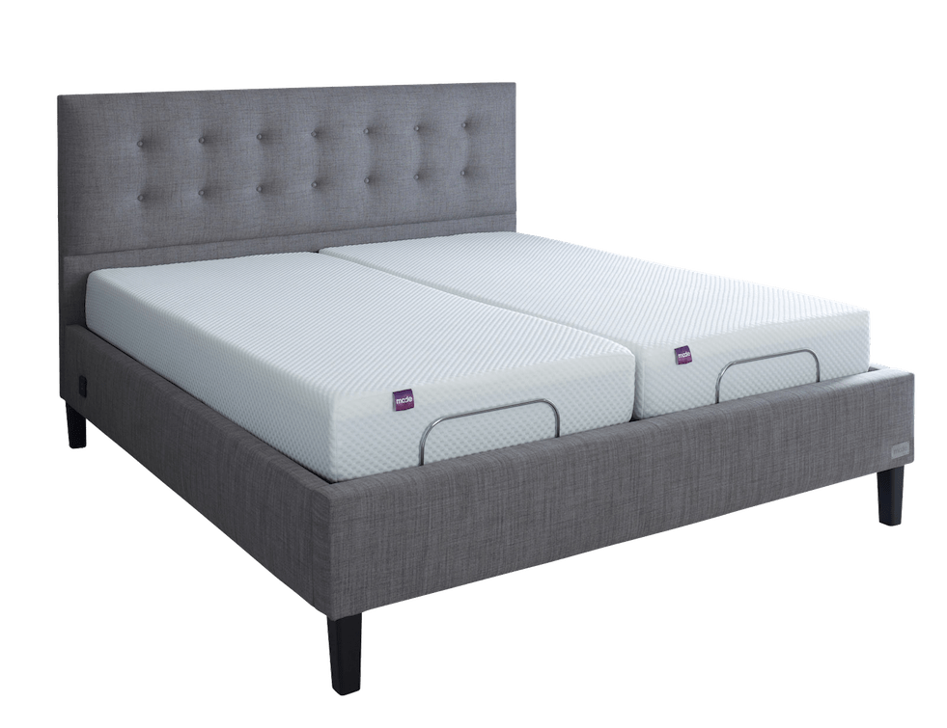

Figure 1: MODE Smart Bed

## (*MODE*, no date)

## Features

* These Smart Beds normally has ability to track your sleep by monitoring necessary measures. With the help of several proximity sensor that are placed over different locations of bed’s surface bed can check respiration, heartbeat, sleep restfulness, and comport to determine the way the system should improve to give better sleep to its user.
* Also, these Smart beds can change / manipulate some physical parameters within it. Such as its temperature, wind flow and inside pressure like wise. Doing so it can, apply settings based on previously collected data. To do so it uses thermo sensors with thermostats, pressure sensors with wind tubes which are built within itself. Even, Mode smart bed has ability to change placements or positions base on previously collected user’s sleep information to improve their sleep. As well system has provided customizable settings based on purpose of user as examples how bed should adjust for user’s reading purposes, sleeping purposes or relaxing purposes like wise.
* These Smart beds have ability to seamlessly connect portable devices such as mobile devices, laptops with help of IoT technologies. Therefor it uses such availability to send daily summarization, healthy sleep tips and other news to your device. Also, Mode Beds Inc. has provided a mobile application that can use to control and monitor your smart bed.

## Strengths

* Mode Smart beds have several mechanisms to monitor users ‘health. Therefore, systems like smart beds have expert knowledge on users’ health and different medical solutions for different conditions. There for Smart Bed system’s expert knowledge on health and medications is a strength of this particular component.
* These smart devices and its interconnected networks tracking and collecting different type of information their users. Cause of that these systems maintain wide variety of information related to different users. As a strength those information holds informative value which can use with machine learning or deep learning.

## Shortcomings

* **System failure**

Like any other system, smart bed systems also face system anomalies, malfunctions and circuit fire outs. Fixing such problem is even costly.

* **Usability limitations**

Normally, Smarts beds are suggested for casual customers. Like health care professional suggests these smart beds can be further improved to use for hospital patients. Therefor it requires necessary patient safety settings.

## Improvements

* Considering above short comes, these kinds of smart beds can be used in hospital with vital changes. Changes like improve comport, prevent patient fall like wise. As further improvement, it can be assembled with digital screen to show patient’s real time information.

SMART LOCKS

Even though market has many types of Smart locks, each of them serves common purpose which is provide access security to your house by facilitating user to enter his out without entering a physical key. Therefore, these systems mostly use wireless and electronic methods authenticate owners. Considering similarities of most Smart Lock products, I choose following product for further analysis. Following Smart lock product is named as Keyless Access Control and developed in Sri Lanka and has market in Sri Lanka, Maldives, Oman.

# KEYLESS ACCESS CONTROL

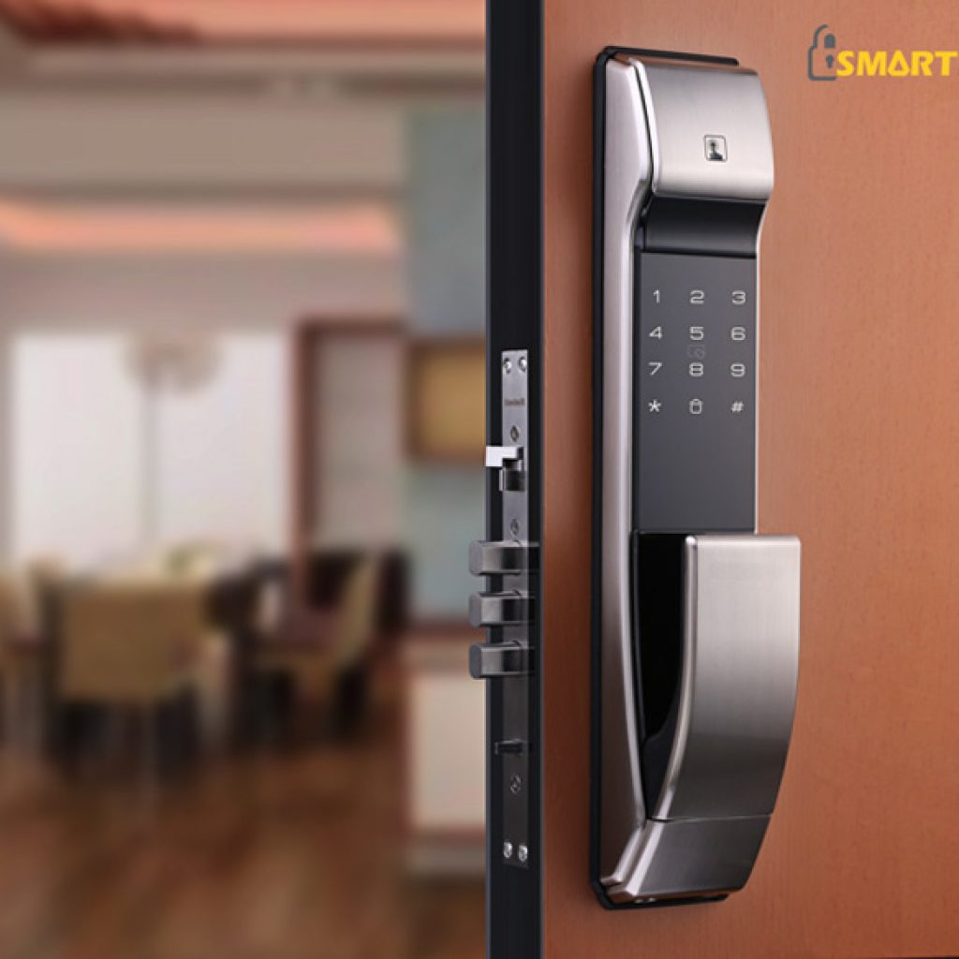

Figure : Smart Lock design of SmartLock.lk

(*SmartLock.LK*, no date)

## Features

* As the signature task / operation, Smart Locks uses wide variety of authentication methods. Most commonly they equip with pin code methods, security tokens or bio metric scanning methods. Some locks provide multiple access options in order to use one method, whenever other method is unable to use.
* These kinds of lock system consist of emergency alert system which use to detect and alarm for burglary, vandalism and even fire. therefor it is important to detect harmful activities within property.

## Strengths

* Since these smart lock systems consist of several methods to lock down premises, each method requires different security key. Therefor user can use secondary method or Bio metric scan method if he forgot security key. Cause of that these devices are reliable and more secure which is a strength of this device.
* This device is used durable material design as outer skin and sealed inside, which is strong. Therefor these devices are hard to break or crack open. Cause of that device has considerable strength to bare some extreme effects.

## Short comes

* These kinds of devices occasionally face technical failures which can occur because of requirement of updates or malfunctions within system. Therefor in such conditions, those lock systems may permanently lockdown the premises and users have to request expertise from professionals. To avoid such conditions user must frequently update system.
* Another short come of this particular type of smart lock system is the requirement of Mobile device to pass security credentials to the system. Cause of that having a charged mobile device is necessary to get accessed. If user haven’t got a mobile device or having device with enough power, make it harder to get accessed. Therefor users must consider such factors as well.

## Improvements

* Existing smart lock systems have features which are manageable but still faces serious issues because of their unreliability. Therefor we can make some suggestions to improve reliability of systems while maintaining robustness. As a suggestion it’s better to have more accessible options within a single system such as having fingerprint mechanism, facial recognition, security questions with given security credential method. Using few methods to accept user entrance is even safer than using a single method. Therefor user can choose default method and customize settings. Therefore, it can resolve problems such as forgetting a password, losing keycard like wise. Even though it maximizes the provided security. As well applying a backup power solution is another design suggestion which can use for power out conditions. Suggestion is to apply integrated solar power supply with back up power plant for such use.

## PART B

SMART BED FOR MORE USES

# ENVIRONMENT

Typically, Smart beds are created for home use and most of existing products doesn’t address issues related to other problem areas such military or hospital like wise. As we believe Smart beds can be have better uses in Hospital environment comparing to Domestic uses. From our design, we’re going to improve several qualities such as comport, mobility with more capabilities which are essential for Hospital background. Hopefully the proposed design will address problems in better way.

# DESIGN

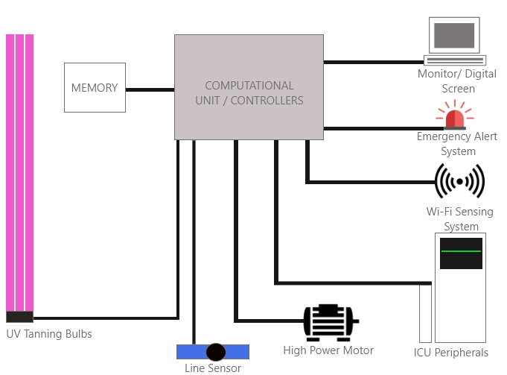

Figure : Suggested Smart Bed for Hospital Use

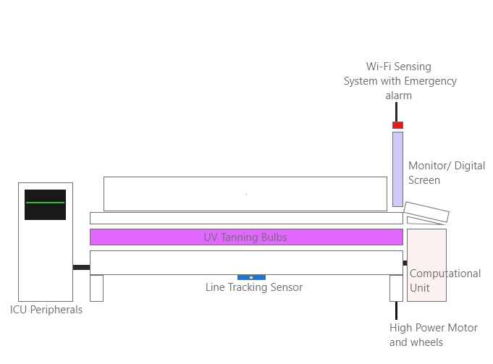

Figure : Design’s Front View

According to proposed design, the bed should have a digital display which is illustrated at the right top corner of Figure 4. Bed itself should provide connecting interfaces (Wired or wireless) for ICU peripherals and the digital display / monitor should have ability to access those devices individually. Emergency alarm will be placed nearby Monitor. Red color Indicated Wi-fi Signal interface will be used to monitor patient / bed in distance. Considering the required range (Short range), Wi-Fi based sensing system such as UWB which is low power consuming and short-range applicable technology is used to monitor such connections (emits from bed side Wi-Fi modules) from one place. Another suggestion is to add germ detection UV light system specifically UV Tanning Bulbs (use for skin therapy and germ protection) under above layer of bed’s mattress (because of their rough edges and cylinder shape). As a further improvement, we decide give mobility for Smart bed by adding high power motors and sensors like Line tracking. Consequently, line tracking sensor will require Black colored rails on surfaces as an additional requirement for path tracking method.

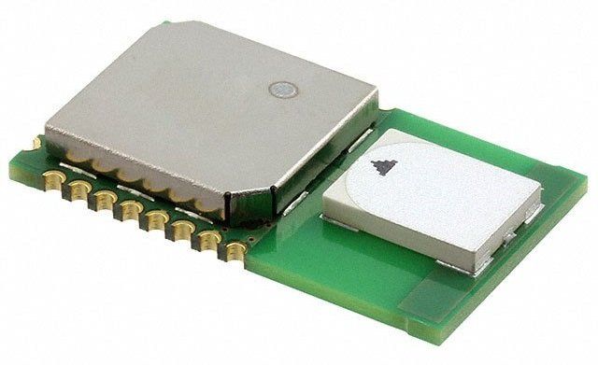

Figure : Ultra-Wideband Module

# 

Figure :ESP8266 Wi-Fi Module

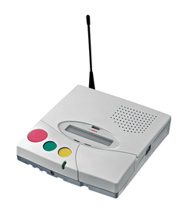

Figure : Nurse Call Emergency System

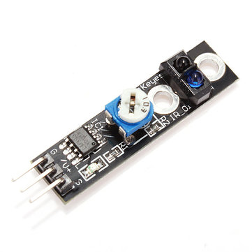

Figure :Line Tracking Sensor

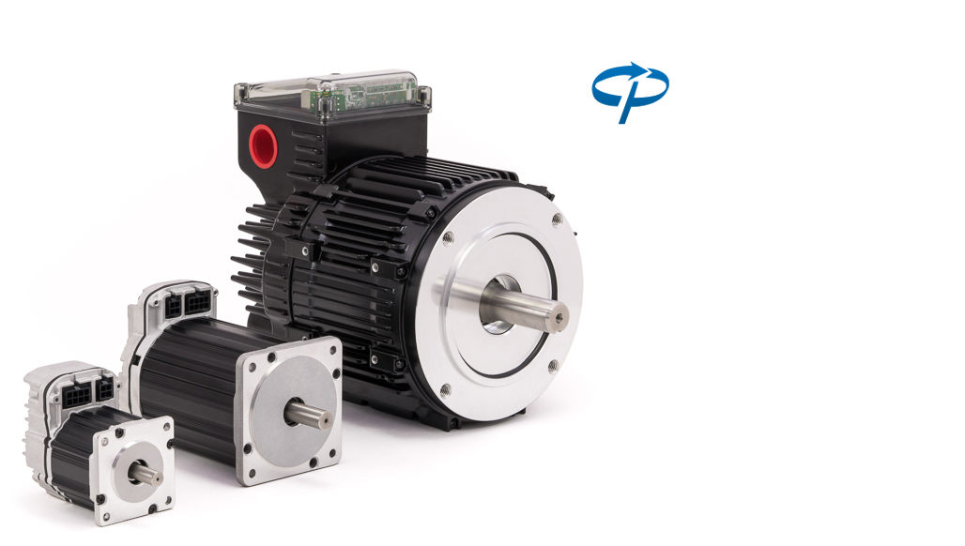

Figure : High Power Sensor Motors

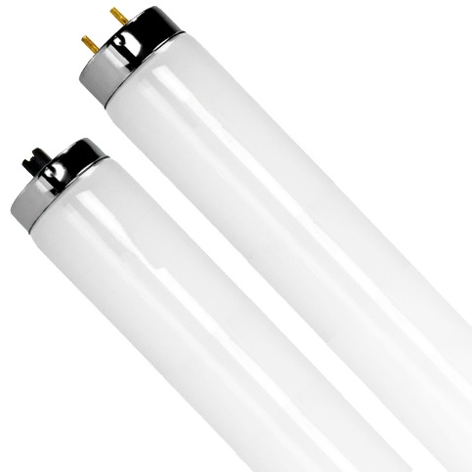

Figure : UV Tanning Bulbs

# FEATURES WITH REASONS

* ICU is the most prioritized section and required more attention in any hospital. Therefor hospitals use more facilities and advanced devices such as bedside monitors, ventilator, Endotracheal Tubes, Intravenous Infusion Pump, Indwelling Urinary Catheter (IDC) like wise. Normally, those devices are contained around and nearby a patient’s bed. In some cases, patient’s beds are assembled with above devices. The system we suggest is completely novel design that uses existing technologies and applications to improve comport, health and satisfaction of the patient. Mainly the proposed design will focus on interconnecting ICU peripherals and given common interface (These kinds of interfaces available in some existing ICU beds) to monitor each necessary information. Doing so it can track patient’s critical conditions and alert using emergency alert mechanism which we supposed to attach proposed system.
* Emergency alert system will use to pre identify patient’s critical conditions. Nurse Call systems are widely using in Hospital environments to detect patient’s emergency conditions. It will help to get attention of responsible persons when it is necessary.
* Wi-Fi based sensing system for remote connectivity is another facility that can work along with emergency alert systems. Considering the requirement of range, high bandwidth communication and power efficiency, technology like UWB (Ultra-Wideband) will be used to detect individual Wi-Fi module that assign for each smart bed. These devices additionally allow hospital staff to remotely monitor patients, video conference with operational staff and even allows to get emergency alerts. This facility can further improve to establish remotely checkup patients.
* ICU rooms need to sanitize frequently in order to keep them germs free. Sanitization ICU rooms happens in daily basis and required to follow predefined set of guidelines. However, we suggest using UV light system to detect and destroy germs. One suggestion was UVC light system which emit waves with harmful wavelength between 200 and 280 nanometers which uses in some hospitals to sanitize under evacuate conditions. However, UV Tanning Bulbs are majorly using in skin light therapy machines and use safer wavelength of Ultraviolet signals. Bar shaped UV tanning bulbs can be placed under layers of bed or front layer of the proposed bed. Doing so we can reduce some amount sanitization procedures and this system may enough to protect patients from germ infections such as bacteria that could lead to yeast infections, viruses and many other infections. Therefor it can give more protection comparing to typical soap and sanitizer products.
* Hospitals often requests maintainable beds for their use which is important for comport working ground. Considering a normal smart bed, they consist of considerable amount of weight with limited movable options such as rotate or shrink like wise. However, those type of beds don’t have and don’t require much horizontal movable options. It’s completely opposite in hospital background and it requires movable options. By adding high Power motors, we can solve above problem. This facility can be further improved by adding line detecting sensors to automatically detect path (dark colored rails on surfaces) which is viable for hospital environments. Even further it can use with Wi-Fi module to remotely control the smart bed.

BIBLIOGRAPHY

*MODE* (no date). Available at: https://www.modebeds.co.uk/contact-us/.

*SmartLock.LK* (no date). Available at: https://www.smartlock.lk/.